# Outlook India Recommendation Engine Project

## Background

Outlook India is a renowned news media website that offers a wide range of news articles covering diverse topics such as national affairs, business, cryptocurrencies, travel, sports, and entertainment. With its extensive coverage and readership, Outlook India aims to provide a personalized and engaging user experience to its visitors. To achieve this, the website is implementing a recommendation system that leverages artificial intelligence techniques.

Recommendation systems have become increasingly vital in the digital media landscape, enabling websites like Outlook India to deliver relevant content tailored to the individual preferences and interests of their users. These systems utilize machine learning algorithms and user data analysis to generate personalized recommendations, ensuring that users are presented with articles and news pieces that align with their specific tastes and preferences. By leveraging the power of recommendation systems, Outlook India aims to enhance user engagement, increase article visibility, and create a more immersive and satisfying reading experience for its audience.

## Objective

Implement a recommendation system by tracking data about articles the user reads on the Outlook India website and recommending similar content.

## Modules

### Cookies

### Module 1 – Cookies

We use JavaScript cookies to track data of articles the user has opened on the website. Separate functions are defined for creating and retrieving cookies. A function is also defined to detect when a page opens and extract the article type and article title from the URL of the page, and then create a cookie and store this information in it. An object is created to keep track of how many of each type of article the user has read. Refer to diagram 1 for flow details.

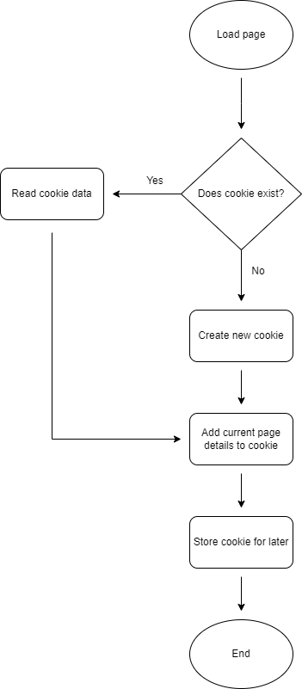

Diagram 1: Cookie module flow

The “current page details” added to the cookie are ‘article type’ (“category”) and ‘article title’, both extracted from the URL.

Thus far, the following article types can be counted as their articles are hosted on the main Outlook India website:

* Business
* Crypto
* Entertainment
* National
* Sports
* Travel